One Object, Many Uses

One Object, Many Uses

Activity Overview
Students explore differences between human and AI creativity by generating uses for everyday objects, comparing responses, and analyzing strengths and limitations of AI creative thinking.
Learning Objective  Students will compare human and AI creative thinking by analyzing different approaches to everyday object use. | Standards & Competencies  - 1b (Understand Mechanics of AI)  - 3a (Be innovative and persistent)  - CCSS.ELA-LITERACY.SL.4-5: Engage in collaborative discussions
Materials  - One common object for demonstration  - Access to AI tool or Screenshot | Preparation  - Pre-generate AI responses for chosen object

Launch and Play (10-12 minutes)
Slide | Exploration Guide
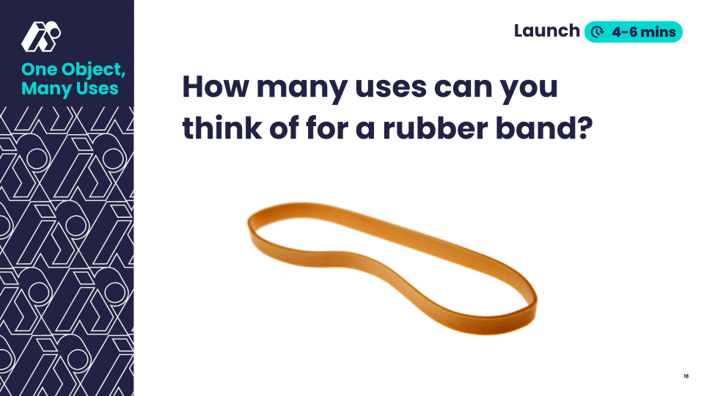 | Say: "Today we're going to explore how humans and AI think creatively. Take turns with your partner sharing different uses for this rubber band. Try to think of creative, unexpected uses, like a pencil grip."  In pairs, students brainstorm for two minutes, then share. Collect and display student ideas.  Look For:  - Unique/unexpected uses  - Listen for patterns in thinking
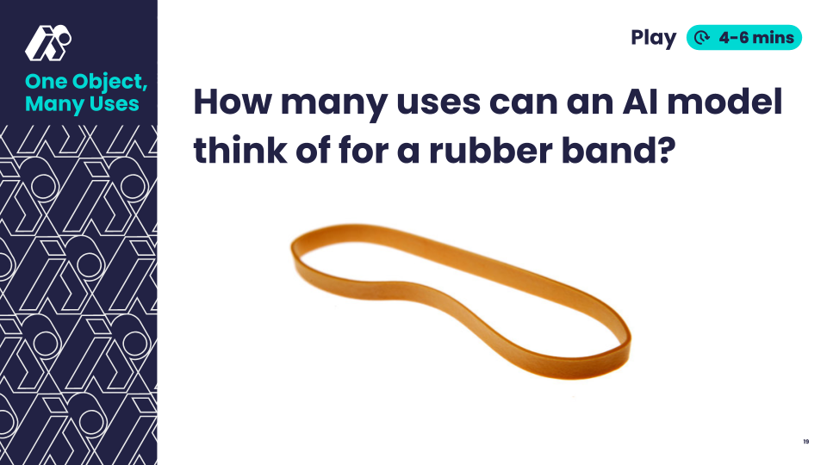 | Say: "Now let's see what an AI suggested. Notice what kinds of ideas it generates."  Share AI-generated responses, either live or via screenshot.  Say: "What patterns do you notice in AI's list? Does anything on the AI list spark a new idea for you?"  Record student responses and new ideas.  Look For:  - Students noticing similarities, differences, and patterns between lists  - “AI generates many ideas quickly, but they may not be good ideas”  Common Student Misconceptions:  - AI is more creative because it knows more.  - Response: Where do AI's ideas come from? How does this affect its creativity?
💡Teaching Tip: Provide groups with rubber bands to help them come up with uses through experimentation. If doing a live AI tool demo, have students craft the prompt, ex. “Come up with as many creative uses for a rubber band as you can.”

Land (5-8 minutes)
Slide | Exploration Guide
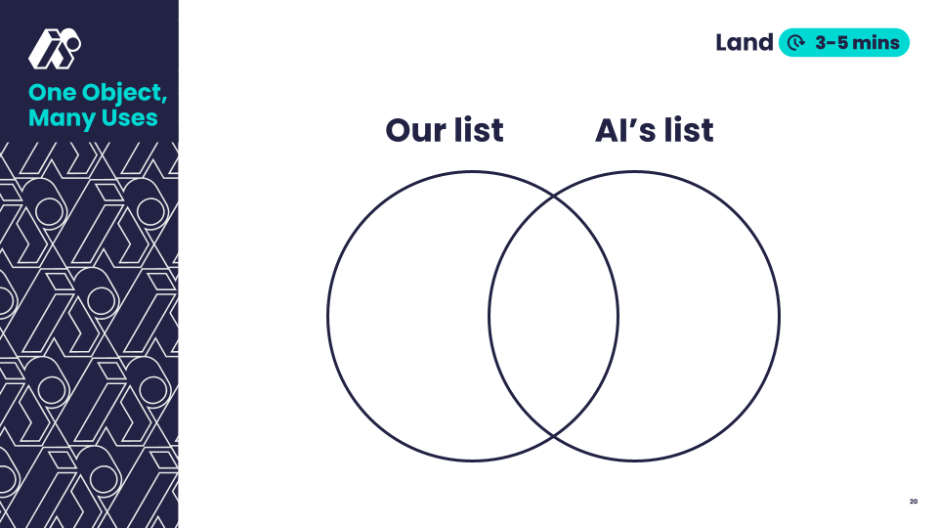 | Say: "Let’s compare and contrast our list with the AI language model’s list. What do you notice about the AI’s ideas? What kinds of things did we think of that the AI didn’t?"  Collect and display student thinking on human vs AI lists.  Say: "One thing to remember is that AI is trained on data that comes from humans, so in a way, AI creativity comes from human creativity."  Look For:  - Human creativity draws from personal experience, emotions, and culture.  - AI can generate many ideas quickly, but it doesnt understand emotions and doesnt have personal experience.  - AI’s ideas may not be that good, but can inspire new ideas in humans.
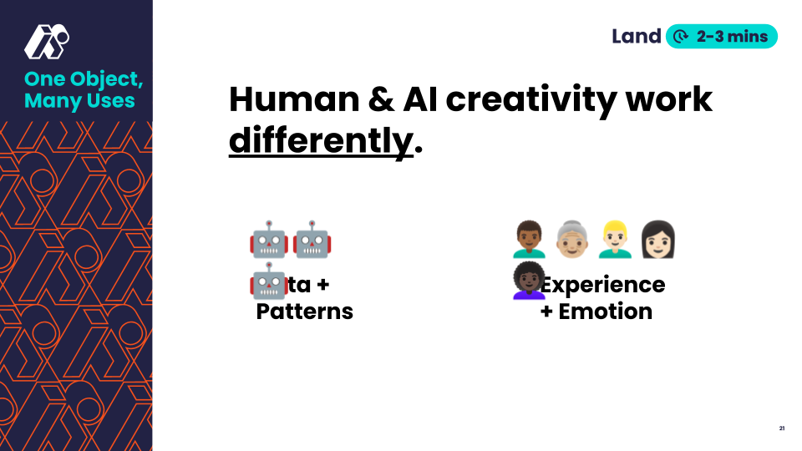 | Say: "Remember: Human and AI creativity work differently. Human creativity is based on emotion and personal experience, while AI finds patterns in large amounts of data (data from humans!) to be creative."
💡Teaching Tip: Provide students a graphic organizer, like a venn diagram, to help them organize their thoughts.

